Book

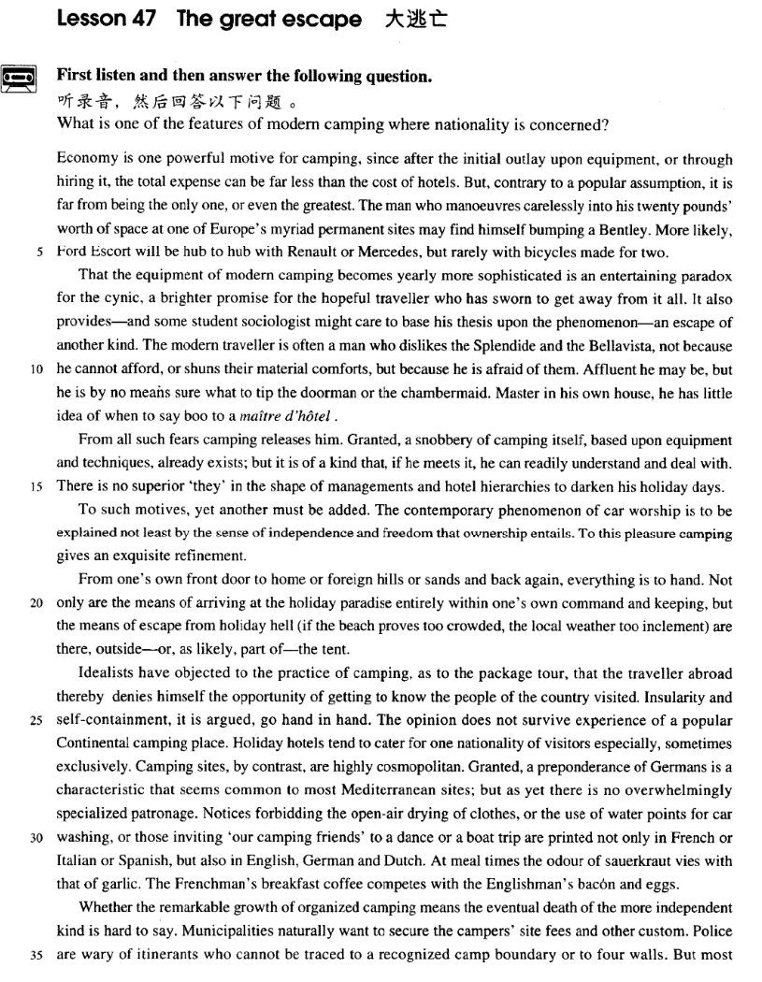

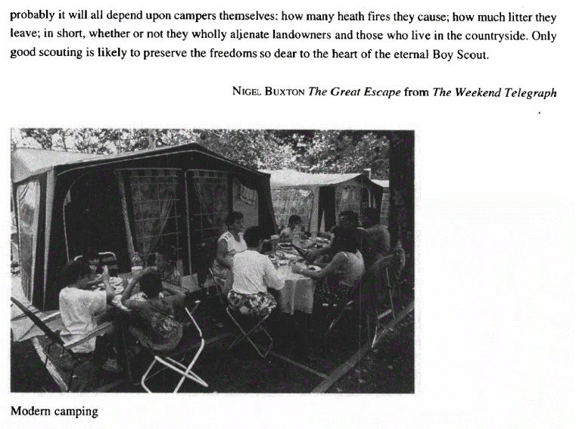

课文

Economy is one powerful motive for camping,

图省钱是露营的一个主要动机，

since after the initial outlay upon equipment, or through hiring it, the total expense can be far less than the cost of hotels.

因为除了开始时购置或是租借一套露营装备外，总费用算起来要比住旅馆开支少得多。

But, contrary to a popular assumption, it is far from being the only one, or even the greatest.

但是，和一般的看法相反，这决非是仅有的，甚至不是最主要的动机。

The man who manoeuvres carelessly into his 20 pounds' worth of space at one of Europe's myriad permanent sites may find himself bumping a Bentley.

如果一位游客漫不经心地驾车驶入欧洲无数常年营地之一，花20镑租用一个空位，那么他可能会碰见一辆本特利汽车，

More likely, Ford Escort will be hub to hub with Renault or Mercedes, but rarely with bicycles made for two.

更可能会望见一辆福特.康索尔或一辆雷诺或一辆梅塞迪斯并排停放着，不过双人自行车则不容易看到。

That the equipment of modern camping becomes yearly more sophisticated is an entertaining paradox for the cynic,

现代露营装备一年比一年讲究，这对那些厌世嫉俗者来说是一件有趣的自相矛盾的事情。

a brighter promise for the hopeful traveller who has sworn to get away from it all.

而对于发誓用露营来摆脱烦恼的人来说，却带来了更光明的前景。

It also provides -- and some student sociologist might care to base his thesis upon the phenomenon -- an escape of another kind.

学社会学的大学生来露营是另一种形式的摆脱现实，他们的目的很可能是根据观察到的露营现象去写论文。

The modern traveller is often a man who dislikes the Splendide and the Bellavista,

现代露营旅游的人往往讨厌在“斯普兰迪德”和“贝拉维斯塔”这样的大酒店，

not because he cannot afford, or shuns their material comforts, but because he is afraid of them.

这并不是因为他们付不起钱，也不是为了躲避物质享受，而是因为他们害怕酒店。

Affluent he may be, but he is by no means sure what to tip the doorman or the chambermaid.

他们可能很富有，但给看门人和房间女服务叫多少小费，心中却根本没有数；

Master in his own house he has little idea of when to say boo to a manager hotel.

他们在家可能是主人，但不知道什么时候才能对酒店的经理表示不满。

From all such fears camping releases him.

露营便人们免除了这些忧虑。

Granted, a snobbery of camping itself, based upon equipment and techniques, already exists;

诚然，露营地本身也存在以露营装备和方式取人的势利现象，

but it is of a kind that, if he meets it, he can readily understand and deal with.

但如果有这种情况，露营者也容易理解，知道如何对付，

There is no superior 'they' in the shape of managements and hotel hierarchies to darken his holiday days.

但在露营地里根本不会有管人的“人上人”和酒店里的等级制度来种露营者的假日过得阴郁低沉。

To such motives, yet another must be added.

除上以动机外，还应加上一个。

The contemporary phenomenon of car worship is to be explained not least by the sense of independence and freedom that ownership entails.

当前崇拜汽车现象可以用与所有权相伴的独立和自由意识来解释。

To this pleasure camping gives an exquisite refinement.

因此开车去露营会给这种快乐意识增加一种优雅意境。

From one's own front door to home or foreign hills or sands and back again, everything is to hand.

从自己的家门出发到国内国外的山区或沙滩上露营然后返回，一切都很便利。

Not only are the means of arriving at the holiday paradise entirely within one's own command and keeping,

完全在自己掌握之中的私人汽车不仅是到达假日天堂的工具，

but the means of escape from holiday hell (if the beach proves too crowded, the local weather too inclement) are there, outside -- or, as likely, part of -- the tent.

而且也是逃离假日地狱（如海滩太挤，当地天气恶劣）方便工具，因为汽车就停在帐篷外面，或者汽车本身可能就是露营帐篷的一个组成部分。

Idealists have objected to the practice of camping, as to the package tour, that the traveller abroad thereby denies himself the opportunity of getting to know the people of the country visited. Insularity and self-containment, it is argued, go hand in hand.

理想主义者像反对旅行社安排一切的一揽子旅游一样反对露营的作法，说这种封闭的作法使到国外旅游者失去了了解所去国家人民的机会。他们争论说，心胸狭窄和自我封闭是并存的。

The opinion does not survive experience of a popular Continental camping place.

但这种说法在受人欢迎的欧洲露营地是站不住脚的。

Holiday hotels tend to cater for one nationality of visitors especially, sometimes exclusively.

假日旅馆有只接待来自一个国家的旅游者的倾向，有时会达到排他的程度。

Camping sites, by contrast, are highly cosmopolitan.

而露营驻地则相反，是高度世界性的。

Granted, a preponderance of Germans is a characteristic that seems common to most Mediterranean sites;

在大多数地中海露营地里，德国人占优势似乎是个普遍现象，确实如此，

but as yet there is no overwhelmingly specialized patronage.

但并没有特别的优待。

Notices forbidding the open-air drying of clothes, or the use of water points for car washing,

禁止露天晒衣服、禁止用水龙头冲洗汽车的布告

or those inviting 'our camping friends' to a dance or a boat trip are printed not only in French or Italian or Spanish, but also in English, German and Dutch.

和邀请露营朋友参加舞会、乘船观光的招贴不仅印志法语、意大利语、西班牙语，而且也印成英语、德语、荷兰语。

At meal times the odour of sauerkraut vies with that of garlic.

用饭的时候，德国泡菜味和大蒜味争相散发，

The Frenchman's breakfast coffee competes with the Englishman's bacon and eggs.

法国人的早点咖啡和英国人的咸肉煎蛋竞相比美。

Whether the remarkable growth of organized camping means the eventual death of the more independent kind is hard to say.

有组织的露营活动的明显发展是否意味着较独立的自我封闭式露营的最终消失，还很难说。

Municipalities naturally want to secure the campers' site fees and other custom.

市政当局当然希望获得露营者的场地费和其他光临的好处，

Police are wary of itinerants who cannot be traced to a recognized camp boundary or to four walls.

警察则对那些查不出有固定营地或住处的游荡者保持警惕。

But most probably it will all depend upon campers themselves: how many heath fires they cause; how much litter they leave;

但最重要的或许是露营者自己，即他们引起了多少场野火，留下了多少垃圾。

in short, whether or not they wholly alienate landowners and those who live in the countryside.

总之，他们是否弄得土地的主人和乡间的居民同他们反目。

Only good scouting is likely to preserve the freedoms so dear to the heart of the eternal Boy Scout.

只有优良的童子军活动才能保持不朽的童子军所衷心热爱的各项自由。

词汇讲解

Lesson 47 The great escape

paradox ['pærədɒks]

n. 矛盾的人、事物或情况；似非而是的话

paradox n. 1. person, thing or situation displaying contradictory features

矛盾的人、事物或情况

He was a paradox―a loner who loved to chat to strangers.

It is a curious paradox that professional comedians often have unhappy personal lives.

paradox n. 2. statement that seems to be absurd or contradictory but is or

may be true 似非而是的话，看似矛盾而实际（或可能）正确的说法

'More haste, less speed' is a well-known paradox. paradoxical adj. 矛盾的；似非而是的

Some sedatives produce the paradoxical effect of making the person more

anxious.

It is paradoxical that if you drink a cup of hot tea it seems to cool you down.

specious adj. seeming to be true or correct, but actually false 似是而非

的

a specious argument / claim

“dox” / “dogma” = opinion

paradox “para” = contrary to n. 矛盾的人、事物或情况；似非而是的话

paradoxical adj. 矛盾的；似非而是的

orthodox “ortho” = right adj. 正统的，传统的，被普遍接受的

dogma n. 教义，教理，教条，信条

dogmatic adj. 教条的，教义的；武断的，自以为是的

dogmatism n. 教条主义，武断

cynic ['sɪnɪk]

n. 愤世嫉俗者

cynic n. person who believes that people do not do things for good, sincere or noble reasons, but only for their own advantage 愤世嫉俗者

Don't be such a cynic!

Even hardened cynics believe the meeting is a step towards peace.

cynical adj. unwilling to believe that people have good, honest, or sincere reasons for doing sth. 愤世嫉俗的

a cynical view of human nature

cynical about

The public is cynical about election promises. cynicism n. [U] cynical attitude 愤世嫉俗affluent ['æfluənt]

adj. 富有的，富裕的

affluent adj. (fml.) having a lot of money and a good standard of living

富有的，富裕的

affluent families

affluent Western countries affluence n. [U] (fml.) 富有，富裕

The 1950s were an age of affluence in America.

rich wealthy affluent prosperous well-off

well-to-do privileged poor needy penniless deprived destitute

underprivileged disadvantaged poverty-stricken snobbery ['snɒbəri]

n. 势利；自命不凡

snob n. 1. (disapproving) a person who admires people in the higher social classes too much and has no respect for people in the lower social classes 势利小人

Dickie disliked snobs intensely.

snobs who despised their working-class son-in-law

snob n. 2. person who feels he has superior tastes, knowledge, etc. 自 命不凡的人

a bunch of intellectual snobs snobbery n. [U] 势利；自命不凡

intellectual snobbery

She accused me of snobbery because I sent my sons to a private school. snobbish adj. 势力的；自命不凡的

I'd expected her to be snobbish but she was warm and friendly.

They had a snobbish dislike for their intellectual and social inferiors. entail [ɪn'teɪl]

v. 需要，带来

entail v. if one thing entails another, it involves it or causes it 需要，带来

entail sth. / doing

That will entail an early start tomorrow morning. It will entail driving a long distance every day.

All mergers entail some job losses.

Such a decision would entail a huge political risk.

The contemporary phenomenon of car worship is to be explained not least by the sense of independence and freedom that ownership entails. entail sb. doing

I’ll never accept parole because that entails me accepting guilt. need / require / demand

call for

This sort of work calls for a high level of concentration.

But can we blame those who looked and failed to see what Galileo saw, if

we remember that to use a telescope at the limit of its powers calls for long experience and intimate familiarity with one's instrument? necessitate sth.

A prolonged drought necessitated the introduction of water rationing. it takes sth. to do sth.

It takes stamina to be a long-distance runner.

It takes a lot of patience to look after a disabled child. insularity [7ɪnsjʊ'lærətɪ]

n. 偏狭

insular adj. 1. of an island 岛的，岛上的

an insular climate / way of life

insular adj. 2. (disapproving) only interested in your own country, ideas, etc. and not in those from outside 偏狭的

insular habits and prejudices

The British are often accused of being insular. insularity n. 岛国性质或状态；偏狭

Insularity and self-containment, it is argued, go hand in hand.

“insul” / “isl” / “isol” = island insular adj. 岛的，岛上的；偏狭的

insularity n. 岛国性质或状态；偏狭

insulate v. 使隔绝，使绝缘

insulation n. 隔绝，绝缘

insulator n. 绝缘体

peninsula “pen” = almost n. 半岛

island n. 岛

isle n. 岛

islet “et” = little n. 小岛isolate v. 使孤立，使隔离isolation n. 孤立，隔离cosmopolitan [7kɔzmə'pɔlitən]

adj. 世界性的，国际性的，有各国人的

cosmopolitan adj. containing people from all over the world 世界性的， 国际性的，有各国人的

a cosmopolitan city / club

the cosmopolitan gatherings at the United Nations Assembly

cosmopolis n. large city inhabited by people from many different countries 国际性大都市

metropolitan adj. relating or belonging to a very large city 大城市的，大

都会的

metropolis n. 大城市，大都会

“polis” / “polit” = city

cosmopolis “cosmo” = world n. 国际性大都市

cosmopolitan adj. 世界性的，国际性的，有各国人的metropolis “metro” = mother n. 大城市，大都会metropolitan adj. 大城市的，大都会的

acropolis “acro” = high n.（古希腊城市的）卫城（多位于山丘之上） megalopolis “megalo” = great n. 大都会区，城市集群

megalopolitan adj. 大都会区的，城市集群的necropolis “necro” = death n. 大型墓地itinerant [aɪ'tɪnərənt]

n. 巡回者，四处游荡者

adj. 巡回的，流动的，四处游荡的

itinerant n. an itinerant is someone whose way of life involves travelling around, usually someone who is poor and homeless 巡回者，四处游荡者homeless itinerants

itinerant adj. from place to place, esp. to work 巡回的，流动的，四处游荡的

itinerant workers / musicians

to lead an itinerant life

itinerary n. a plan or list of the places you will visit on a journey 行程， 旅行计划

Visits to four different countries are included in your itinerary. “it” = to go

itinerant n. 巡回者，四处游荡者；adj. 巡回的，流动的，四处游荡的

itinerary n. 行程，旅行计划

initial “in” = into adj. 最初的；n. 姓名首字母；v. 签姓名首字母

initiate v. 发起，创始；接纳……为新成员

initiation n. 发起，创始；入会

initiator n. 发起人，创始者

initiative n. 积极性，主动性；主动权

circuit “circu” = round n. 环行线，周线；电路

circuitous adj. 迂回的，曲折的transit “trans” = across n. 运输transition n. 过渡

transitional adj. 过渡性的

alienate ['eɪliəneɪt]

v. 使不友好，使疏远，使反目

alienate v. to do sth. that makes sb. unfriendly or unwilling to support you

使不友好，使疏远，使反目

The latest tax proposals will alienate many voters.

The government cannot afford to alienate either group.

alienated adj. feeling that you do not belong in a particular society, place, or group 疏远的，疏离的

alienated from …

Many single parents feel alienated from society.

Gina had become increasingly alienated from her family.

alienation n. [U] the feeling of not being part of society or a group 疏远， 疏离

alienation from …

Unemployment may provoke a sense of alienation from society. “ali” = other

alias n. 别名，化名，假名

alibi “bi” = place n. 某人不在犯罪现场的申辩或证明

alien n. 外国人，外星人；adj. 外国的，外星的，陌生的，格格不入的

alienate v. 使不友好，使疏远，使反目alienated adj. 疏远的，疏离的alienation n. 疏远，疏离

alienable adj. 可转让的，可让渡的

unalienable “un” = not adj. 不可剥夺的

We hold these truths to be self-evident, that all men are created equal, that they are endowed by the Creator with certain unalienable rights, that among these are life, liberty, and the pursuit of happiness.

― Thomas Jefferson

Economy is one powerful motive for camping, since after the initial

outlay upon equipment, *or through hiring it*, the total expense can be far

less than the cost of hotels. economy n. 1. 经济

The Chinese economy grows at an annual rate of 8 per cent.

economy n. 2. 节 约practice economy 厉行节约motive for / behind sth.

the motive for the murder

the motive behind the bombing

Marine Studio biologists have pointed out that, however intelligent they may be, it is probably a mistake to credit dolphins with any motive *of*

lifesaving.

The motive for / behind the bombing is revenge. the motive of revenge

outlay on / upon …

the spending or disbursement of money 花费；支出

= expense / cost of …

the weekly outlay *on* groceries

Economy is one powerful motive for camping, since after the initial outlay *upon* equipment, or through hiring it, the total expense can be far less than the cost *of* hotels.

But, *contrary to a popular assumption*, it is far from being the only one, or even the greatest.

contrary to …

contrary to popular opinion / belief

contrary to a popular assumption contrary to expectations

popular belief that classical music is too complex, it achieves a simplicity that only a genius can create.

(A) Subject to (B) Contrary to

(C) Familiar to (D) Similar to

far from …: 根本不是……，远非…… far from (being) + n. / adj.

far from doing

Your work is far from (being) satisfactory.

The show was far from (being) a failure; it was a great success. Far from relieving my cough, the medicine aggravated it.

He doesn't like rock and roll.

It's a long way to the record store.

He likes only rock and roll.

He isn't hot now that he has a fan.

W: You are not much of a rock’n-roll fan, are you?

M: It’s far from being my favorite kind of music, that's for sure. Q: What does the man imply?

Answer: (A) He doesn't like rock and roll.

…, or (it is) even (far from being) the greatest (one).

Contrary to a popular assumption, spiders are far from being insects, or even related to them.

The man who manoeuvres carelessly into his twenty pounds' worth of space at one of Europe's myriad permanent sites may find himself *bumping a Bentley*.

manoeuvre / maneuver v. to move or turn skillfully or to move or turn sth. skillfully, esp. sth. large and heavy 运用技巧移动或使转弯

The pilot maneuvered to avoid the bird.

We attempted to maneuver the canoe closer to him.

金钱 + worth of + 物品

fifty pence worth of trouble

They had got away with thousands of pounds worth of diamonds. Ross: Well, how was the date?

Rachel: Well I’m alone and I just bought fifteen dollars worth of candy bars, what do you think?

myriad adj. (fml.) uncountably many 无数的

the myriad fish in the ocean

*More likely*, Ford Escort will be hub to hub with Renault or Mercedes, but

rarely with bicycles *made for two*. to 紧靠着，面对着

stand face to face

sit back to back dance cheek to cheek

cars queuing bumper to bumper I’d like to reserve a table for two.

That the equipment of modern camping becomes yearly more sophisticated is an entertaining paradox *for the cynic*, a brighter promise *for the hopeful traveler who has sworn to get away from it all*.

That all great art has this power of suggesting a world beyond is undeniable.

yearly

adj. 每年的

adv. 每 年 = annually get away: have a holiday

get away from it all: have a thoroughly relaxing holiday You need to get away from it all for a couple of months.

It also provides—and some student sociologist might care to base his thesis upon the phenomenon—an escape of another kind.

a student teacher / nurse 实习教师、实习护士

care for sth. / to do sth. (fml.)

= want sth. / to do sth.

Would you care for a drink? Would you care to go to a walk?

base … on / upon … phenomenon / phenomena

criterion / criteria

The modern traveller is often a man who dislikes the Splendide and the Bellavista, not *because he cannot afford, or shuns their material comforts*, but *because he is afraid of them*.

not … but …

What is called 'modern civilization' is not the result of a balanced development of all man's nature, but of accumulated knowledge applied to practical life.

not that … but that …

不是因为……, 而是因为……

Not that I love Caesar less, but that I love Rome more.

— Shakespeare ‘Julius Caesar’

It is / was not that … but (that) … 不是因为……, 而是因为……

It was not that I actually remembered anything at all. But my father had described over and over again what we should see at every milestone after leaving the nearest town.

It is not that the scales in the one case, and the balance in the other, differ in the principles of their construction or manner of working; but that the latter is a much finer apparatus and of course much more accurate in its

measurement than the former.

shun v. to deliberately avoid sb. or sth. 避免，避开，回避

shun luxury / temptation / publicity

comforts n. [pl.] the things that make your life nicer and more comfortable, esp. things that are not necessary 使人感觉舒适享受的事物

hotels with all the modern comforts

After the trip, it was nice getting back to a few home comforts.

By comparison, ferry trips or cruises offer a great variety of civilized comforts.

Affluent he may be, but he is by no means sure what to tip the doorman or the chambermaid.

Affluent he may be, but he is by no means sure what to tip the doorman or the chambermaid.

He may be affluent, but he is by no means sure what to tip the doorman or the chambermaid.

主题性前置 Thematic Fronting

宾语前置

Smoking he absolutely loathes.

The President praised the loyalists, but the rebels he declared traitors.

宾语补足语前置

A scandal I call it.

I knew you were careless, but dishonest I never thought you.

主语补足语前置

3-1. 主语较短时，常不用倒装语序。

Very strange it was.

Not dogs, but half-tamed wolves they seemed.

Affluent he may be, but he is by no means sure what to tip the doorman or the chambermaid.

3-2. 主语较复杂时，常用倒装语序（系动词提至主语之前）。

Gone *are* the days when China had to depend on foreign oil. What’s the interest rate?

What’s the balance in my account?

What’s today’s exchange rate for U.S. dollars?

*Master in his own house*, he has little idea of when to say boo to a maître d'hôtel.

A man of few words, David declined to express his opinion.

Writer and music lover, Anne was chosen as a co-author of the book. Who is (the) captain of the team?

boo n. sound made to show disapproval or contempt 呸（表示不赞成或

唾弃）

maître d’hôtel n. the person in charge of a restaurant or of the people who bring food to your table in a restaurant 饭店经理或服务生领班

From all such fears camping releases him.

Camping releases him from all such fears. release … from … 释放 ，解脱

Granted, a snobbery of camping itself, based upon equipment and

techniques, already exists; but it is of a kind that, *if he meets it*, he can readily understand and deal with.

granted , …, but …

的确, ……, 但是 ……

Granted, China is still a developing country, but she is full of potential. granted (that) …, …

Granted that China is still a developing country, but she is full of potential.

It is / was true that …, but …

It was true that he had just bought a lamb, he explained, but his lamb was black.

It is true that during their explorations they often faced difficulties and dangers of the most perilous nature, equipped in a manner with would make a modern climber shudder at the thought, but they did not go out of their way to court such excitement.

It is true that China is still a developing country, but she is full of potential.

It is true that / Admittedly, / Granted, ..., but that is not to say that ... / it

does not follow that …/ it does not necessarily mean that ... / there is no

guarantee that …

readily adv. 1. willingly

2. without difficulty; easily

The equipment was cheap and readily available.

The information is readily accessible on the Internet.

Greater too than we can describe; for language, which was invented to convey the meanings of this world, cannot readily be fitted to the uses of another.

There is no superior 'they' in the shape of managements and hotel

hierarchies *to darken his holiday days*. be superior to …

be inferior to … be senior to … be junior to … be prior to …

be posterior to …

in the shape / form of …

The majority of the patients attending the medical out-patients departments of our hospitals feel that they have not received adequate treatment unless they are able to carry home with them some tangible remedy in the shape of a bottle of medicine, a box of pills, or a small jar of ointment, and the doctor in charge of the department is only too ready

to provide them with these requirements.

Convinced of the importance of education, modern states 'invest' in institutions of learning to get back 'interest' in the form of a large group of enlightened young men and women who are potential leaders.

To such motives, yet another must be added. yet / still *another / one more*…

yet one more question still another example

This led to yet another angry argument.

She was yet another victim, reduced to a screaming wreck.

The contemporary phenomenon of car worship is to be explained not least by the sense of independence and freedom *that ownership entails*. be to do (fml.) 的四种用法

打算，想要

I am to see her tomorrow.

But instruments far more delicate than that were needed if any really serious advance was to be made.

命令

You’re to be back by 10 o’clock. No one is to leave the building.

能够

How am I to pay such a debt?

We Chinese people are not to be bullied.

应该

Such men are to be pitied rather than despised.

As soon as he had hung up, he went over to the workmen and told them that if a policeman ordered them to go away, they were not to take him seriously.

Some books are to be tasted, others to be swallowed, and some few to be chewed and digested.

— Francis Bacon not least: (fml.) especially, in particular 尤其是，特别是

The film caused a lot of bad feeling, not least among the workers whose

lives it described.

My mother was upset about his appearance here, not least because she felt it was invading her privacy.

the sense of independence / freedom / direction / humor / justice / pride / honor / accomplishment / responsibility / superiority / inferiority

The sense of humor is mysteriously bound up with national characteristics.

No matter how much we like honey, or how much we have read about the uncanny sense of direction which bees possess, we have a horror of being stung.

*To this pleasure* camping gives an exquisite refinement.

Camping gives an exquisite refinement *to this pleasure*.

exquisite adj. very sensitive and delicate in the way you behave or do things 高雅的

She has exquisite taste in art.

The wind then speaks the message of the sun to the sea and the sea transmits it on through waves—an ancient, exquisite, powerful message. refinement n. [U] culture or elegance of manners, taste, language, etc. 高

雅，文雅，优雅

a person of great refinement an atmosphere of refinement

From one's own front door to home or foreign hills or sands and back again, everything is to hand.

home adj. in one’s own country, domestic 国内的

the home market 国内市场

home news 国内新闻

sand n. [U and C] an area of beach 沙滩

miles of golden sands

to hand Br.E. sth. that is to hand is close to you, so that you can reach it easily 近在咫尺，近在手边

For those of you who don't have an atlas to hand, Newcastle is a city in

the north-east of England.

Not only *are* the means *of arriving at the holiday paradise* entirely within

one's own command and keeping, but the means *of escape from holiday hell (if the beach proves too crowded, the local weather too inclement)* are there, outside—*or, as likely, part of—*the tent.

command n. [U, sing] ability to use or control sth., mastery 使用或控制

某事物的能力，掌握

He has (a) good command of the French language. 他精通法语。He has enormous funds at his command. 他掌握着巨额资金。keeping n. 保管，保存

I’ll leave the keys in your keeping. 我把钥匙交你保管。

inclement adj. (fml.) inclement weather is unpleasantly cold, wet etc 严寒的，狂风暴雨的，恶劣的

inclement weather 恶劣的天气

clement adj. (fml.) (esp. of weather) mild （尤指天气）温和的

clement weather

as likely = as likely as not: very probably 很可能

As likely as not, the meeting will take place in the village pub. As likely as not she's forgotten all about it.

Idealists have objected to the practice of camping, *as to the package tour*, that the traveller abroad thereby denies himself the opportunity of getting to know the people of the country *visited*.

object to (doing) sth. 反对（做）某事

Robson strongly objected to the terms of the contract.

I objected to having to rewrite the article. object that …

The group objected that the policy would prevent patients from receiving the best treatment.

object to (doing) sth. that …

package tour n. a vacation arranged by a travel company for a fixed price that includes the cost of your hotel and transportation, and sometimes meals and entertainment 由旅行社安排一切的一揽子旅游

Idealists have objected to the practice of camping, as (idealists have

objected) to the package tour, that the traveller abroad thereby denies himself the opportunity of getting to know the people of the country visited.

On the occasions when they have pushed to shore an unconscious human being they have much more likely done it out of curiosity or for sport, as (they have done it out of curiosity or for sport) in riding the bow waves of a ship.

thereby adv. (fml.) with the result that sth. else happens 藉以，从而，由

此

He became a citizen in 1978, thereby gaining the right to vote.

deny oneself sth. (fml.) to refuse to let yourself have sth. that you would like to have, esp. for moral or religious reasons 不让自己拥有……

He denied himself *all pleasures and luxuries*.

get to like / know / understand sb / sth: to gradually begin to like, know, or understand sb. or sth.

It'll take a while for you to get to know everyone. After a while, I got to like him.

Insularity and self-containment, it is argued, go hand in hand.

it is argued that insularity and self-containment go hand in hand. Insularity and self-containment, it is argued, go hand in hand.

It seems that dogs love to chew up money. Dogs, it seems, love to chew up money.

self-contained adj. (of a person) not needing the company of others, reserved （指人）不需与他人来往的，拘谨的

self-containment n. 不与他人来往，拘谨

go hand in hand: if two things go hand in hand, they are closely connected

Wealth and power go hand in hand in most societies.

The opinion does not survive experience *of a popular Continental*

*camping place*.

survive v. continue to live or exist in spite of nearly being killed or destroyed by sth.经历……幸存

survive an earthquake

Few buildings survived the bombing raids intact. The plants may not survive severe winters.

Holiday hotels tend to cater for one nationality of visitors especially, sometimes exclusively.

(Br.E.) cater for sb./sth. = (Am.E.) cater to sb./sth.: to provide the things that a particular person or situation needs or wants 满足，迎合

The class caters for all ability ranges.

Shops cater for the do-it-yourself craze not only by running special advisory services for novices, but by offering consumers bits and pieces which they can assemble at home.

an LA bank catering to Asian businesses

They only publish novels which cater to the mass market.

exclusively adv. used for emphasizing that sth. is available to or limited to one specific thing or group 独享地，排他地

a club exclusively for women

Camping sites, *by contrast*, are highly cosmopolitan.

Granted, a preponderance of Germans is a characteristic that seems common to most Mediterranean sites; but as yet there is no overwhelmingly specialized patronage.

a preponderance of sb./sth.: if there is a preponderance of people or things of a particular type in a group, there are more of that type than of any other

There is a preponderance of female students in the music department. A preponderance of the students in the program came from overseas.

as yet: until now 到现在为止（常用于否定句）

an as yet unpublished document

As yet little is known of the causes of the disease.

specialized adj. trained, designed, or developed for a particular purpose, type of work, place etc. 专门的

specialized training for specific jobs

the highly specialized plants that live in desert areas

patronage n. customer’s support for a shop, restaurant, etc. 光临，惠顾

We thank you for your patronage.

Notices forbidding the open-air drying of clothes, or the use of water

points for car washing, or those inviting 'our camping friends' to a dance or a boat trip are printed not only in French or Italian or Spanish, but also in English, German and Dutch.

water point n. 供水点，饮水点

dance n. [C] social gathering at which people dance 舞会

to hold a dance in the village hall

*At meal times* the odour of sauerkraut vies with that of garlic.

odour (US odor) n. (pleasant or unpleasant) smell （香的或臭的）气味

the delicious odor of freshly-made coffee the unpleasant odor of over-ripe cheese

vie v. to compete with other people to achieve or obtain sth. 竞争

Six candidates are currently vying *for* the Democratic presidential

nomination.

The two older children tend to vie *with* the younger one for their mother's attention.

The Frenchman's breakfast coffee competes with the Englishman's bacon

and eggs.

Whether the remarkable growth of organized camping means *the eventual death of the more independent kind* is hard to say.

Municipalities naturally want to secure the campers' site fees and other

custom.

municipality n. a town, city or district with its own local government; the group of officials who govern it 自治市；市政当局

secure v. obtain sth., sometimes with difficulty 得到某事物（有时有困

难）

We’ll need to secure a bank loan.

They’ve secured government backing for the project.

custom n. [U] regular purchases from a tradesman, shop, etc. 经常向某商人、商店等购物，惠顾

We would like to have your custom. 我们欢迎您经常惠顾。

We’ve lost a lot of custom since our prices went up. 自从提价以后, 我们失去了许多顾客的生意。

Police are wary of itinerants who cannot be traced to a recognized camp

boundary or to four walls.

wary adj. looking out for possible danger or difficulty; cautious （对可能发生的危险或困难）留意的，小心的，警惕的

keep a wary eye on sb. 密切注意某人

She was wary of strangers. 她很警惕陌生人。

be wary of giving offence 唯恐冒犯他人

trace sb./sth. to sth.: to find or discover sb./sth. by looking carefully for them/it

We finally traced him to an address in Chicago.

four walls (spoken) the room that you are in, esp. considered as a private place 私人住处

I don't want anything repeated outside these four walls.

But most probably it will all depend upon campers themselves: *how many heath fires they cause; how much litter they leave; in short, whether or not they wholly alienate landowners and those who live in the countryside*.

heath n. area of flat uncultivated land, esp. one covered with shrubs; moorland 荒地（尤指灌木丛生之处）; 荒野

Only good scouting is likely to preserve the freedoms *so dear to the heart*

*of the eternal Boy Scout*.

scouting n. [U] the activities that Scouts take part in 童子军活动

eternal adj. without beginning or end; lasting or existing for ever 永 久的，永恒的，不朽的

the Eternal God 上帝eternal life 永生eternal love 永恒的爱

Boy Scout n. a member of a worldwide organization of young men and boys, founded in England in 1908, for character development and citizenship training 童子军：1908 年在英国成立的世界性的少男或男

孩组织的一员，目的是进行性格发展和品德训练